**Lab 1 - Proximity Connect Product Description**

Jon Rossy

Old Dominion University

CS 411W

Spring 2024

Professor Janet Brunelle

April 15, 2024

Version 3

**Table of Contents**

1. Introduction…………………………………………………………………………………...............................................3

2. Proximity Connect Product Description…………………………………………………………..............................5

2.1 Key Proximity Connect Product Features and Capabilities…………………………………………………..5

2.2 Major Functional Components Diagram (Hardware/Software)…………………………….................7

3. Identification of the Case Study………………………………………………………………………………………………….8

4. Proximity Connect Product Prototype Description………………………………………………........................9

4.1. Prototype Architecture (Hardware/Software)………………………………………………........................9

4.2. Prototype Features and Capabilities…………………………………………………………………………………10

4.3. Prototype Development Challenges………………………………………………………............................12

5. Glossary…………………………………………………………………………………………............................................13

6. References………………………………………………………………………………………...........................................16

**List of Figures**

Figure 1: Proximity Connect Real-World Major Functional Components Diagram…………………………….8

Figure 2: Proximity Connect Prototype Major Functional Components Diagram………………………………10

**List of Tables**

Table 1: Proximity Connect User Interface Features Table………………………………………………………………..6

Table 2: Proximity Connect Back-end Development Features Table………………………………………………….7

Table 3: Prototype Features Table………………………………………………………...............................................11

# 1 Introduction

After the Coronavirus pandemic, face-to-face communication holds greater significance in an increasingly fragmented world. Obstacles exist that decrease the ability to absorb information and communicate effectively, especially when the retention of information is required for success. To mitigate obstacles, in-person communication must be prioritized in the workforce and higher education instead of technological communication.

The Media Naturalness Theory explains the first obstacle which is the assumption that the human brain has evolved to facilitate face-to-face communication and that the more similar a method of human communication is to face-to-face communication, the less brain power required to adjust to the new method of human communication (Karl et al., 2022). The five sub-principles of the theory are colocation, synchronicity, facial observation, body language observation, and speech. How closely a method of communication handles these five sub-principles compared to face-to-face communication is primarily what determines how beneficial a communication method is to the human brain in terms of the lack of severe adjustment the brain requires the closer a communication method is to face-to-face communication (Karl et al., 2022).

The second obstacle is that in-person informal meetings often occur in noisy surroundings, disrupting the smooth exchange of information. In contrast, there are approximately 55 million workplace meetings per week, totaling 11 million daily and over a billion annually, with an average span of three hours. (Flynn, 2023) In addition, on average, employees attend eight meetings each week; among them, 47% prefer in-person meetings, highlighting the need for clear communication (Flynn, 2023). Frequent meetings lead to information overload, resulting in information loss. This underscores the importance of meeting transcripts for in-person workplaces and informal meetings where technology can be employed to record the meeting session.

The third obstacle is the Ebbinghaus effect which explains the gradual decline in humanity’s memory retention over time. Many individuals also experience hearing impairments, and the deaf and hard-of-hearing communities account for 19% of the global population (Current World Population 2024). The large amount of people who are deaf or hard of hearing emphasizes the need for meeting transcription in face-to-face interactions. The deaf and hard-of-hearing communities must not be excluded because they are outnumbered compared to the hearing-able person.

As an effect of globalization, cities and businesses have increasingly diverse populations which are comprised of a larger percentage of non-native speakers than ever. Language barriers are common, causing potential miscommunication when meetings are conducted in a language foreign to a majority of meeting participants. A solution is required to fix these challenges and facilitate clear communication in face-to-face settings. Proximity Connect resolves these issues, enabling seamless in-person connections using Bluetooth technology so that all meeting participants can communicate with each other in real time.

**2 Proximity Connect Product Description**

Proximity Connect is an Android smartphone application designed to aid in in-person

Communication using an ad-hoc network of proximity smart devices held by meeting speakers and attendees for increased conversation flow and to aid users in recalling past meetings. Users create an account username and password along with a display name for meetings that is able to be changed. Users are able to add a profile picture and add friends for networking and joining meetings. Proximity Connect transcribes and translates the speech of individuals connected locally via Bluetooth and keeps a text transcript of all speech and speaker names for all meeting attendees to view. Proximity Connect leverages state-of-the-art systems already in place on smartphones to facilitate text-based versions of spoken words.

**2.1 Key Proximity Connect Product Features and Capabilities**

Proximity Connect’s main niche is establishing a phone network to transcribe and translate conversations among group members to increase comprehension and communication. Real-world applications of Proximity Connect include students reviewing past lectures and employees increasing information flow in workplace meetings. Proximity Connect is capable of minimizing the human issue of memory loss regardless of user severity because of the product’s ability to capture and save all conversations.

Proximity Connect is especially relevant, given the business preference for face-to-face meetings emphasizing the need to minimize communication hurdles in face-to-face settings along with enabling real-time communication and facilitating real-time communication understanding. Using Proximity Connect, meeting participants can talk in a nonnative language while ensuring understanding of the information. Proximity Connect aids information retention by providing detailed text logs of meeting conversations and speaker notations in the user's native language, allowing for reference. Table 1 defines Proximity Connect’s User Interface features, feature descriptions, user roles, and access capability.

**Table 1**

*Proximity Connect User Interface Features Table*

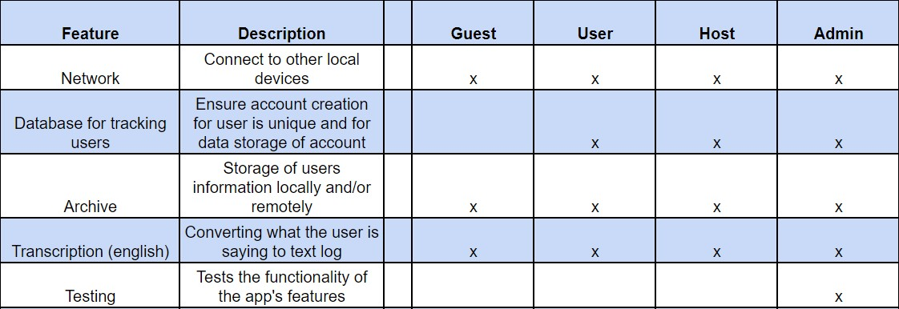

Table 2 defines Proximity Connect’s Back-end Development features. First, the four Proximity Connect user roles, and second, which features the roles can utilize. Last, a short description of each Back-end Development feature is defined.

**Table 2**

*Proximity Connect Back-end Development Features Table*

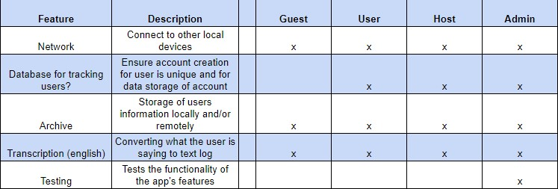

**2.2 Major Components (Hardware/Software)**

Hardware tools include a computer for software development and databases, an Android phone with Bluetooth capability, and Internet access for users. Software tools include the front-end languages of HTML, CSS, JavaScript, and React and the back-end languages of Java, MySQL, and C#. The IDE tools include the IDE of Android Studio for Android emulation for testing and development, the Git version control and GitLab repository, and the Trello project management. Users need to link their email and create a password to have access to user privileges. Without a Proximity Connect account, users only have access to guest privileges. Data is managed using SQLite for Android where users’ username, password, and personal data files including transcription titles, names, and profile images are stored.

Proximity Connect uses AssemblyAI to convert the users’ speech to transcribed text. For example, every person at an in-person workplace meeting connects via Proximity Connect’s Bluetooth functionality. Next, a user speaks as the input for the AssemblyAi which then outputs the spoken words into a transcribed text that the user can save and view at any time. Figure 1 illustrates Proximity Connect’s Real-World Major Functional Component Diagram.

**Figure 1**

*Proximity Connect Major Functional Component Diagram*

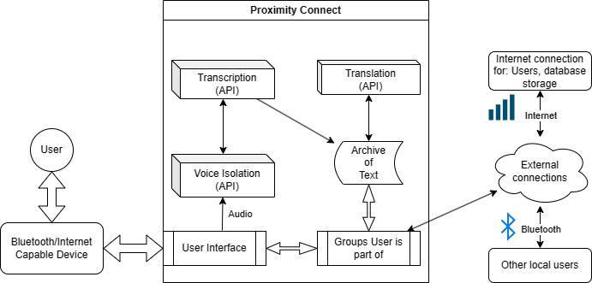

# 3 Identification of Case Study

Proximity Connect’s prototype case study focuses on assisting in organizing professional gatherings for Old Dominion University (ODU) Computer Science (CS) Department faculty, students, club members, colloquium, and interviews. The purpose of Proximity Connect’s case study is to show proof of concept that aids in conducting meetings affected by language barriers, managing meetings held in loud surroundings that disrupt information exchange, recalling details from past meetings, addressing the difficulties associated with in-person meetings, and handling meetings where a participant might have hearing difficulties.

Proximity Connect’s real-world product development is targeted at other ODU departments, other universities, business professionals, frequent travelers, meetings among friends and family, people with neurological disorders such as Auditory Processing Disorder and Attention-Deficit/Hyperactivity Disorder, and English as a foreign language/English as a second language students. The development and testing of Proximity Connect utilizes a model of Old Dominion University’s Computer Science Department with fake faculty, students, and staff conducting both formal and informal face-to-face meetings.

**4 Proximity Connect Product Prototype Description**

Proximity Connect’s prototype product contains account creation/login, user groups, archived access to transcribed/translated (English only) logs, invitations to meetings, databases with user information, and the ability to name the archived log. Proximity Connect’s prototype product does not contain a calendar where the user can schedule and join meetings, a board for displaying meeting rules, the ability to share recordings, the ability to mark specific points throughout a meeting for review, the ability to personalize the user interface, and more languages available for translation and transcription. For the case study, testers assume the role of all users, and analytics are collected to show the proper working of all innovative aspects and that Proximity Connect functions properly.

**4.1 Major Components (Hardware/Software)**

First, Proximity Connect uses MySQL Server for database management, JUNIT for prototype testing, and Microsoft Visual Studio and Android Studio IDEs for software development. Second, Proximity Connect Javadoc documentation for in-code comments, and Git Version Control and GitLab Repository for keeping track of file changes and edits. Third, the front-end aspects of Proximity Connect are built with HTML, CSS, JavaScript, and React Programming languages while the back-end aspects of Proximity Connect are built with Java and C#. Figure 2 illustrates Proximity Connect’s Prototype Major Functional Components Diagram.

**Figure 2**

*Proximity Connect Prototype Major Functional Component Diagram*

**4.2 Prototype Features and Capabilities**

Proximity Connect’s Prototype Features include noise filtering of audio input, clean audio transcribed into text, screen-displayed text, and node network connection through Bluetooth. Table 3 displays Proximity Connect’s Prototype Features Table. The Prototype Features Table includes all features of Proximity Connect and divides them into color-coded categories based on whether the feature is fully implemented or not in the prototype version of Proximity Connect. Green represents a feature that is fully implemented, yellow represents a feature that is partially implemented, and red represents a feature that is not implemented.

**Table 3**

*Prototype Features Table*

# 4.3 Prototype Development Challenges

Some of the development challenges in implementing the prototype design include connecting users’ phones using the Node network, configuring the use of Proximity Connect in offline settings, and Interacting with the necessary APIs. Similarly, developing the initial prototype app user interfaces and connecting the user interfaces with the database proved to be difficult. Solving these development challenges is crucial in making a successful prototype that properly displays Proximity Connect at its fullest potential.

## 5 Glossary

**ANDROID:** An operating system developed primarily for mobile devices by Google, characterized by its open-source nature, diverse app ecosystem, and customizable user interface.

**ANDROID STUDIO:** An integrated development environment (IDE) designed by Google for Android app development, providing tools, emulators, and a comprehensive environment for coding, debugging, and testing applications for the Android platform.

**API:** A software intermediary that enables applications to access and utilize specific functions or services provided by another software or platform.

**BLUETOOTH:** A wireless technology standard used for short-range communication between devices, enabling data exchange and connectivity without the need for cables.

**C#:** A programming language developed by Microsoft, primarily used for building a wide range of applications on the .NET framework.

**Coqui Ai:** an open-source initiative providing accessible tools and models for speech recognition and natural language processing.

**CSS:** A style sheet language used to define the presentation and formatting of HTML (Hypertext Markup Language) and XML (Extensible Markup Language) documents.

**Deaf:** Lacking the power of hearing or having impaired hearing.

**GIT:** A distributed version control system that enables multiple developers to collaborate on projects by tracking changes to source code, managing revisions, and facilitating the merging of different versions, enhancing team collaboration and software development workflows.

**GitLab:** A web-based platform for DevOps lifecycle management, providing a comprehensive set of tools for version control, issue tracking, continuous integration, and deployment.

**Hard of Hearing:** Not able to hear well.

**HTML:** The standard markup language used for creating web pages and structuring their content by employing a system of tags to define elements such as text, images, links, and multimedia.

**IDE:** A software application consolidating various tools and features necessary for software development, typically including a code editor, debugger, build automation tools, and a compiler or interpreter.

**iOS:** Operating system developed by Apple for use on mobile devices like iPhones, iPads, iPod touch, etc. It provides the interface and framework for running applications and managing the device’s hardware and software.

**JAVA:** A programming language known for platform independence, allowing developers to write code that can be run on various devices. Commonly used for building applications, from mobile apps to web applications and large-scale enterprise systems.

**JAVASCRIPT:** A programming language used primarily to create interactive effects and dynamic content on websites, enabling functionality such as forms, animations, and user interactions with web browsers.

**JUnit:** A tool used in programming for testing Java code to ensure it works as expected, helping developers identify and fix errors or bugs in their programs.

**MySQL:** A type of database software that helps store and organize information, commonly used for websites and applications to manage data efficiently.

**Open API:** A specification for building APIs that facilitates easy comprehension and interaction with web services. Enables developers to define, document, and describe Restful APIs using a structured and standardized format.

**REACT:** A popular JavaScript library used for building user interfaces in web applications. Enables developers to create interactive and reusable UI components.

**RNNoise:** An open-source, real-time noise suppression software that uses signal processing and deep learning.

**TRELLO:** Web-based project management tool that uses boards, lists, and cards to organize tasks and facilitate collaboration among team members.

**VISUAL STUDIO:** An IDE made by Microsoft that supports various programming languages.

## 6 References

Blackwell, D. L., Lucas, J. W., & Clarke, T. C. (2014). Summary health statistics for U.S. adults: National Health Interview Survey, 2012 (PDF). *National Center for Health Statistics. Vital Health Stat, 10*(260).

Flynn, J. (2023, July 7). 28+ incredible meeting statistics [2023]: Virtual, Zoom, in-person meetings and productivity. 28+ INCREDIBLE MEETING STATISTICS [2023]: VIRTUAL, ZOOM, IN-PERSON MEETINGS AND PRODUCTIVITY. https://www.zippia.com/advice/meeting-statistics/

Hoffman, H. J., Dobie, R. A., Losonczy, K. G., Thermann, C. L., & Flamme, G. A. (2016, December). Declining Prevalence of Hearing Loss in US Adults Aged 20 to 69 Years. *JAMA Otolaryngology - Head & Neck Surgery*. December 2016 Online.

Lin, F. R., Niparko, J. K., & Ferrucci, L. (2011, November 14). Hearing loss prevalence in the United States. [Letter] *Arch Intern Med, 171*(20), 1851-1852.

Mykhalevych, N. (2023a, October 13). Survey: Why America is obsessed with subtitles. *Language l learning with Preply Blog*. https://preply.com/en/blog/americas-subtitles-use/

Stritto, M., & Linder, K. (n.d.). A rising tide: How closed captions can benefit all students. *EDUCAUSE Review*. <https://er.educause.edu/articles/2017/8/a-rising-tide-how-closed-captionscan-benefit-> all-students

U.S. Department of Health and Human Services. (n.d.). Quick statistics about hearing. *National Institute of Deafness and Other Communication Disorders*. https://www.nidcd.nih.gov/health/statistics/quick-statistics-hearing

University, Utah State. Benefits of Captions. *Utah State University*[.](http://www.usu.edu/accessibility/captions/benefits)  [www.usu.edu/accessibility/captions/benefits](http://www.usu.edu/accessibility/captions/benefits)

*What is captioning?* National Association of the Deaf. (n.d.).

<https://www.nad.org/resources/technology/captioning>[-for-access/what-is-captioning/](https://www.nad.org/resources/technology/captioning-for-access/what-is-captioning/)

Xrai Glass Alternatives & Competitors. *CB Insights*, www.cbinsights.com/company/xraiglass/alternatives-competitors.

*Current world population*. Worldometer. (n.d.). https://www.worldometers.info/worldpopulation/

Cusak Anne. (2009, July 1). *A child wears a cochlear implant in Los Angeles.* Getty Images.

<https://slate.com/human>[-interest/2016/01/whats-it-like-for-a-deaf-person-to-hear-for-the-](https://slate.com/human-interest/2016/01/whats-it-like-for-a-deaf-person-to-hear-for-the-first-time.html) [firsttime.html](https://slate.com/human-interest/2016/01/whats-it-like-for-a-deaf-person-to-hear-for-the-first-time.html)

Baldwin Ann. (2009, April 02). *Senior man shrugging shoulders stock photo*. iStock.

<https://www.istockphoto.com/photo/senior>[-man-shrugging-shoulders-gm91520053-8977854](https://www.istockphoto.com/photo/senior-man-shrugging-shoulders-gm91520053-8977854)

(2023). *What is Language Barrier and How to Overcome It*. gurmentor. <https://gurmentor.com/what>[is-language-barrier-and-how-to-overcome-it/](https://gurmentor.com/what-is-language-barrier-and-how-to-overcome-it/)

(2021). *Hear the whole conversation.* easylisteninghearing*.*<https://easylisteninghearingcenters.com>[/](https://easylisteninghearingcenters.com/)

(2023) *Shield free icon*. flaticon.<https://www.flaticon.com/free-icon/shield_8017361>

Rawpixel. (2023). pinterest*.* [*https://www.pinterest.com/pin/people-connected-and-networking-*](https://www.pinterest.com/pin/people-connected-and-networking--620793129867142323/)[*620793129867142323/*](https://www.pinterest.com/pin/people-connected-and-networking--620793129867142323/)

Mundell, E.J. (2018, April). *Drinking may worsen hearing loss at loud concerts*. UPI.

<https://www.upi.com/Health_News/2018/04/19/Drinking>[-may-worsen-hearing-loss-at-](https://www.upi.com/Health_News/2018/04/19/Drinking-may-worsen-hearing-loss-at-loud-concerts/8331524193752/) [loudconcerts/8331524193752/](https://www.upi.com/Health_News/2018/04/19/Drinking-may-worsen-hearing-loss-at-loud-concerts/8331524193752/)

*Browse People Network*

*Icons*. thenounproject. <https://thenounproject.com/browse/icons/term/people-network/>

Bridge. (2023, September 25). *10 facts and stats about learning retention*. Bridge. <https://www.getbridge.com/blog/learning-analytics/10-stats-about-learning-retention-youll-> wantforget/

Forbes Magazine. (2023, August 29). *Deafness and hearing loss statistics*. Forbes. https://www.forbes.com/health/hearing-aids/deafness-statistics/

Ding, C., Wu, Y., Chen, X., Chen, Y., Wu, Z., Lin, Z., Kang, D., Fang, W., & Chen, F. (2022, November 29). *Global, regional, and national burden and attributable risk factors of neurological disorders: The global burden of disease study 1990-2019*. Frontiers in public health. https://www.ncbi.nlm.nih.gov/pmc/articles/PMC9745318/

Statista. (2023, August 31). *Global tourism industry - statistics & facts*. Statista. https://www.statista.com/topics/962/global-tourism/#topicOverview

Beare, K. (2019, November 18). *How many people learn English?* ThoughtCo. https://www.thoughtco.com/how-many-people-learn-english-globally-1210367